10.1.5 Editors - Geometry Node Editor - Header - Add Menu
Add menu 1
Add menu - Search 1

Add menu

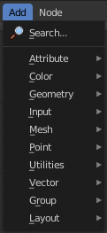
Here you will find all the nodes that you need to create your geometry node trees. A click at one of the items will create the node in the workspace at the mouse position right under the menu. It is already selected, and you can drag it around.

Add menu - Search

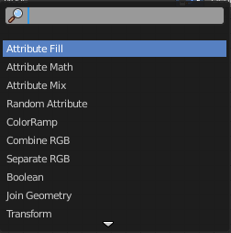
This is a search menu where you can search for specific node types in all categories.

